**SQL STATEMENTS: -** B.RISHITHA

192324130

Create table Movie:

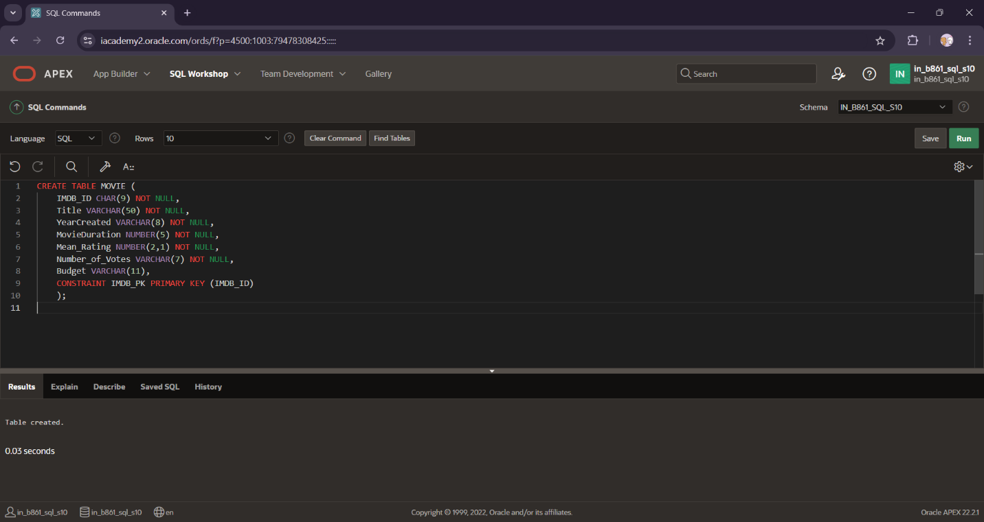

Create table Persons:

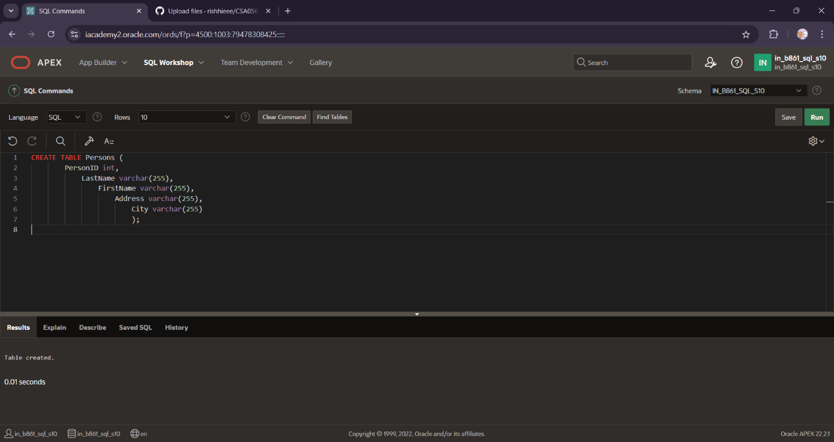

Create table EMPLOYEES:

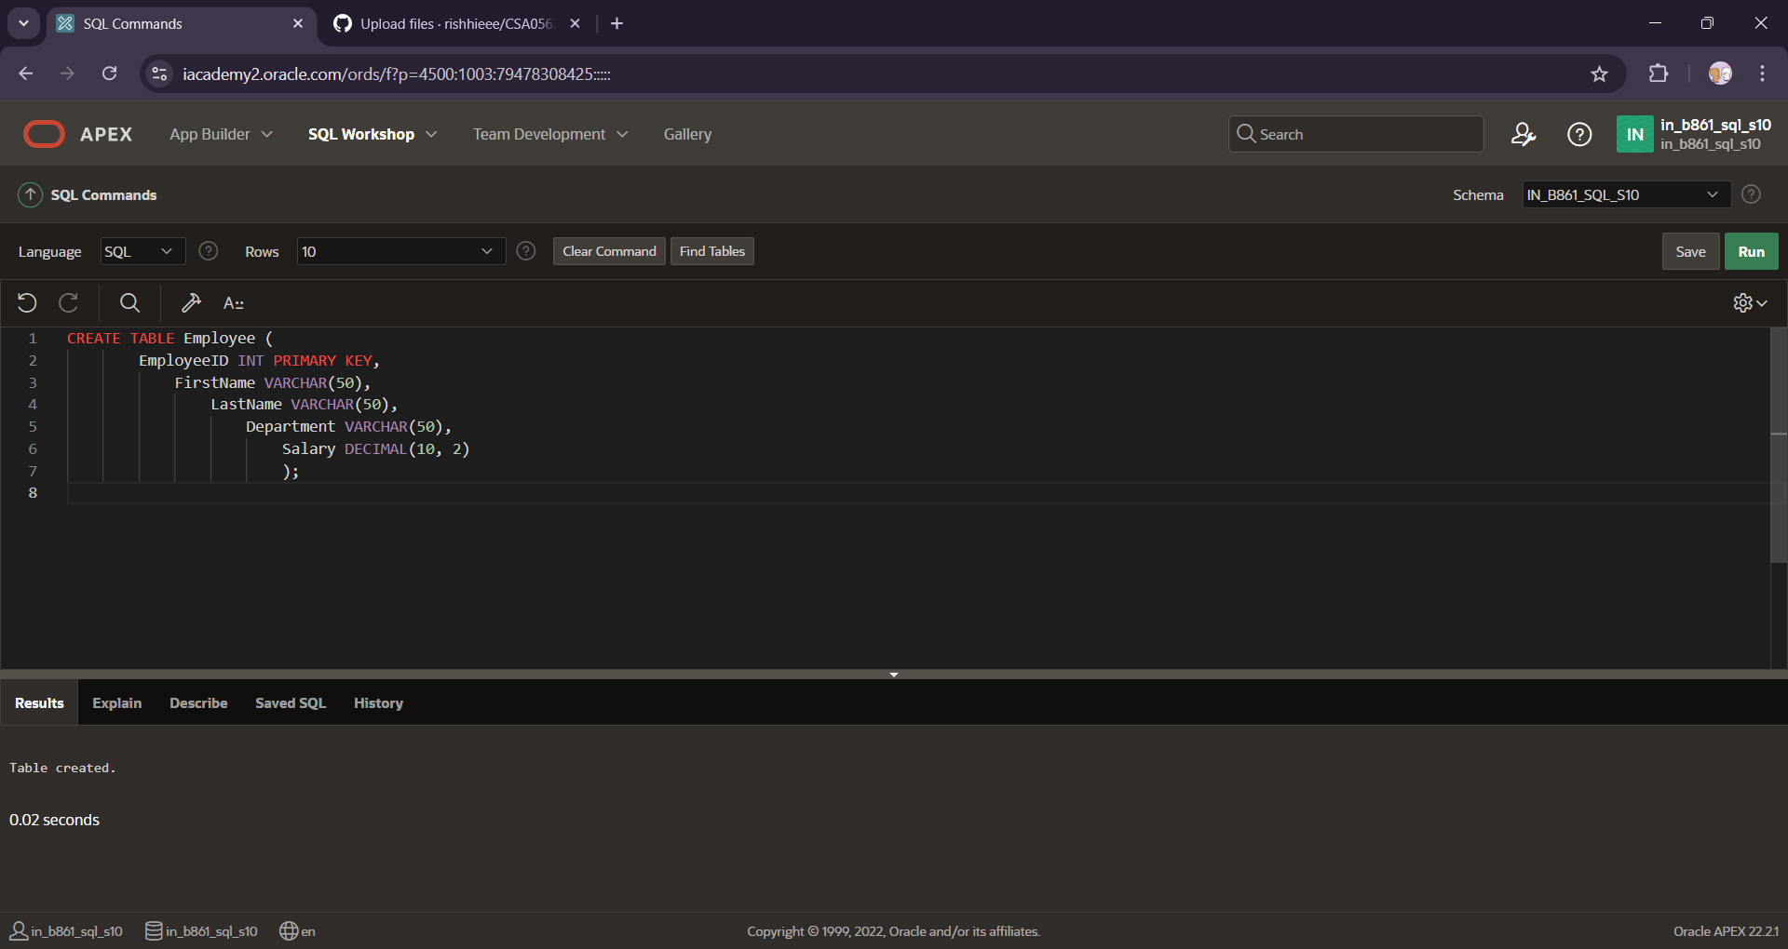

CREATE TABLE CUSTOMER:

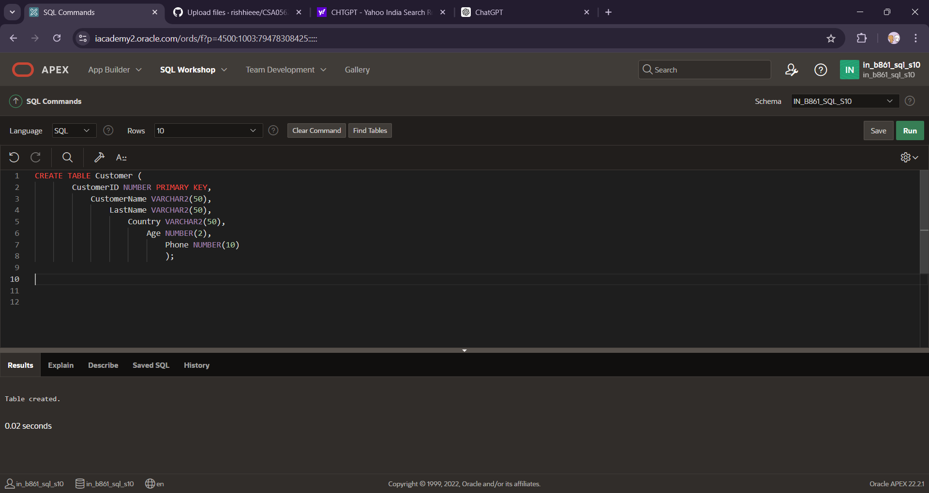

Inserting the values into customers table:

